Deployment Guide version 1.0.0

Contents

1.0 Introduction. 2

2.0 Environment Setup 2

2.1 Supported Operating System. 2

3.0 Configuration. 2

3.1 Database System 2

3.2 Backend Application. 3

3.3 Frontend application. 3

4.0 Conclusion 5

**Abbreviations**.

|  |
| --- |
| **API** – Application Programming Interface. |
| **ADMIN** – Administrator. |
| **Npm** – Node Package Manager. |
| **URL** – Universal Resource Locator. |
| **MVP** – Most Viable Product |

## 1.0 Introduction.

This document contains the steps and procedures that will deploy. If followed stepwise you will have the API running as well as the ADMIN interface.

## 2.0 Environment Setup

- Have a code editor e.g. Visual Studio

- Install nodeJS, ReactJS

- Create an account with MongoDB and get a connection string that will be used in connecting the backend application to this database system.

### 2.1 Supported Operating System.

The API is supported by all operating systems, including:

* windows Server 64bit
* Solaris 64bit
* RHEL 64bit

Make sure your are running the following versions, of tools:

NodeJS version 18.15.0

Npm version 9.5.0

MongoDB version 16.0

React version 16.8.0

## 3.0 Configuration.

### 3.1 Database System

Create an account and click on **CONNECT** to get the connection string

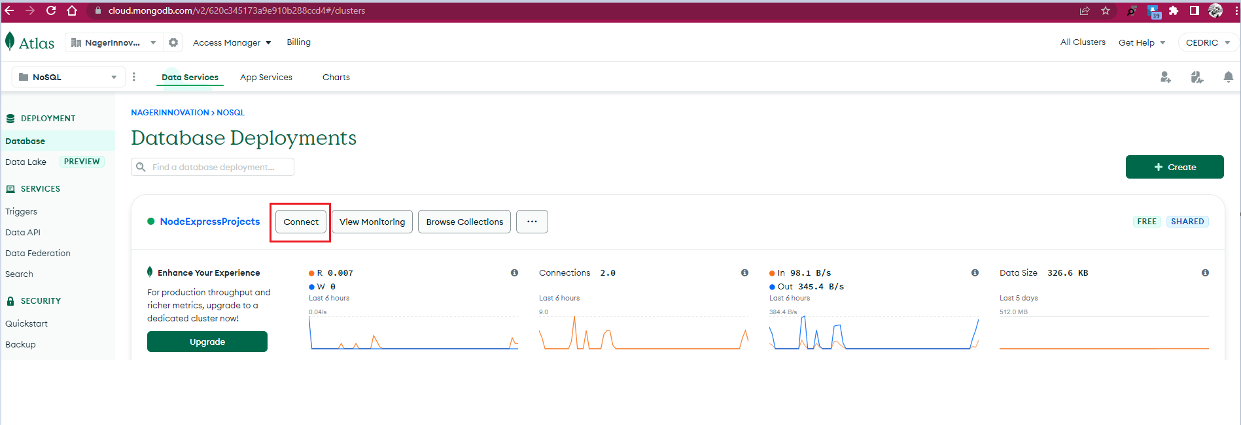

Bind the String to **MONGODB_URI** in the environment file, **.env**

**Example:**

MONGODB_URI="mongodb+srv://cedu:<PASSWORD>@nodeexpressprojects.qv4az.mongodb.net/”

### 3.2 Backend Application.

Use a Port number of your choice by setting the environment variable **PORT** the default is **5000.**

Configure the starting of the backend application to **npm run start** command.

The **API documentation** can be accessed through

*<HOSTNAME>: <PORT>/api-docs*

### 3.3 Frontend application.

Run this application using

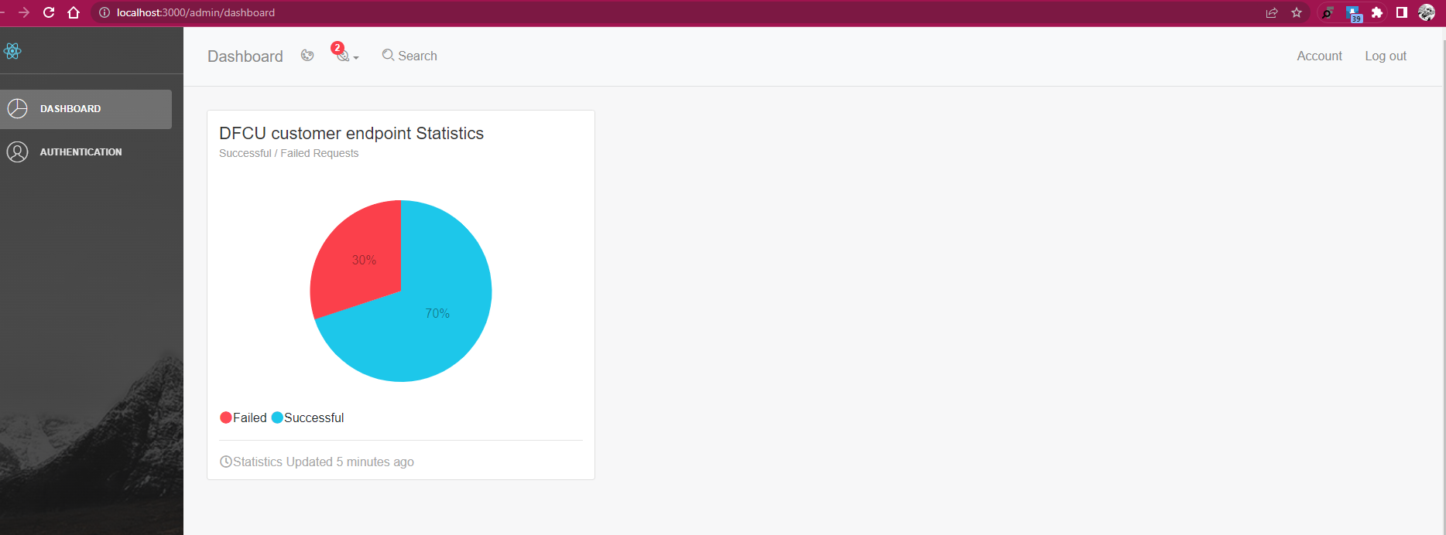

Deploy this application found in the **client folder** to a hosting site and configure the **backend URL** in the **client/src/config/configs.js** file.

The dashboard is using firebase authentication which is already setup as below:

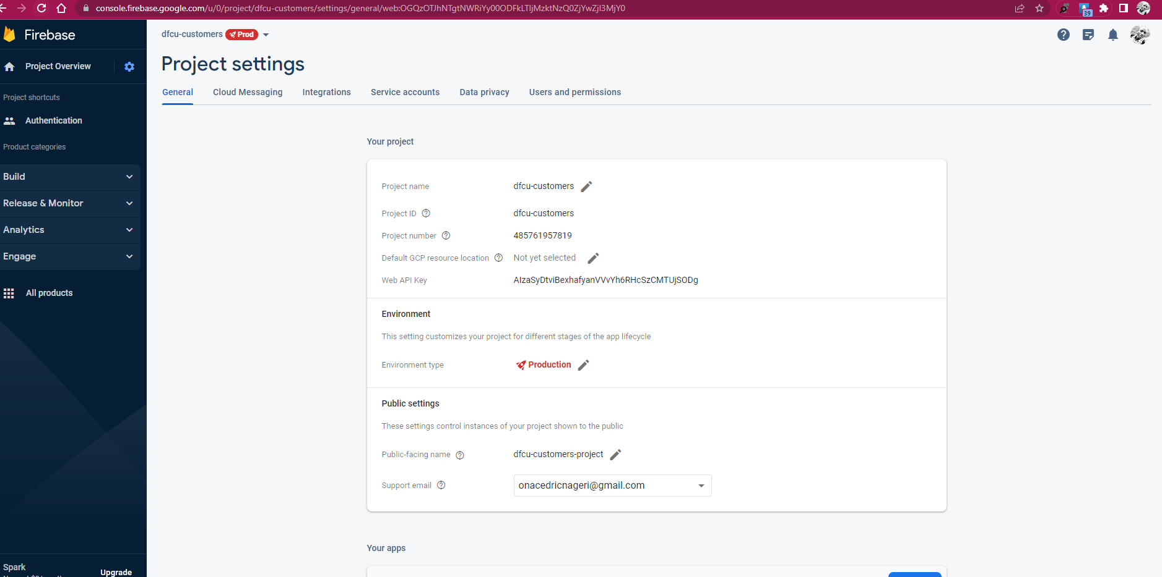

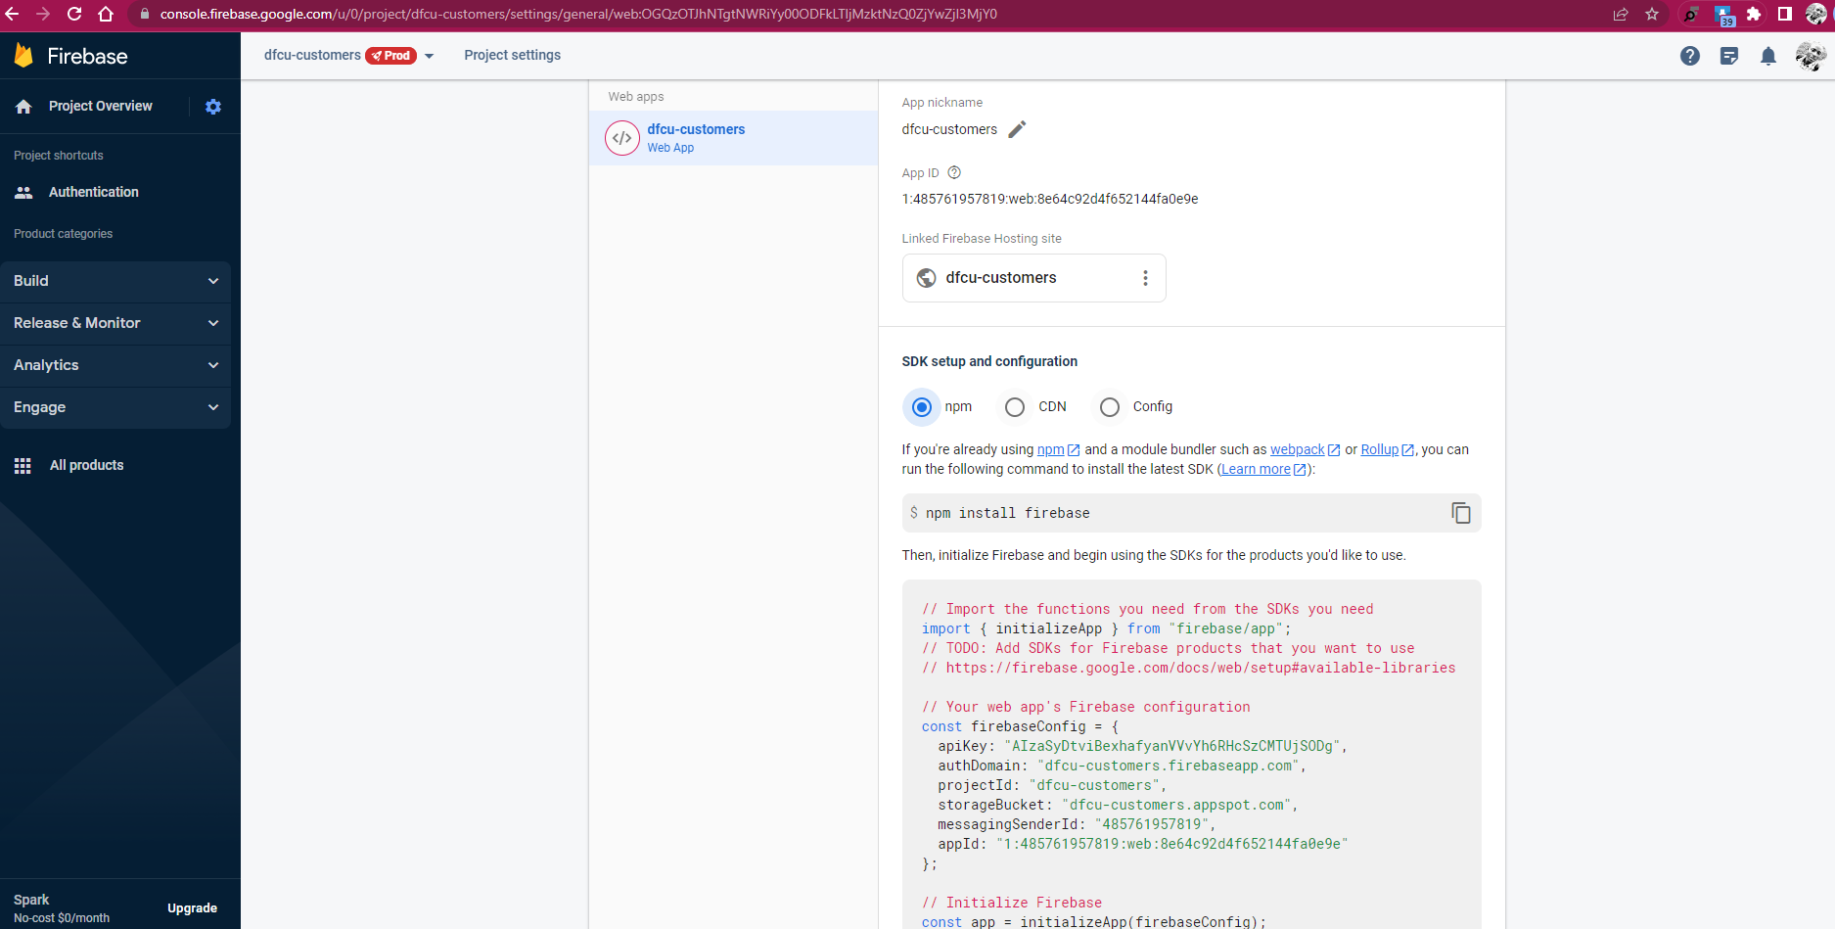

The authentication is not fully functional.

## 4.0 Conclusion

This is the MVP for version 1.0.0